**Business Intelligence Guidebook**

**Templates**

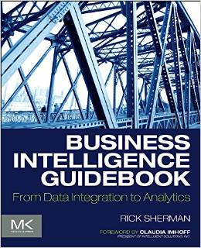

**Chapter 11:**

**Data Integration Design Template**



[Company Name]

Data Integration Design Template

[Project Name]

Date: [Select Date]

Author(s):

Sponsor(s):

Table of Contents

Data Intergation Design 4

Data Sources 4

SOR Tables 4

SOR Table - Queries 6

Source to Target (S2T) Mappings 7

• S2T Mappings - Rows matching selection criteria 7

• S2T Mappings – SOR Joins 7

• S2T Mappings - Rows not matching selection criteria 8

Data Integration Workflow 9

Approvals 10

Appendix: Background Materials 11

Authors and contributors 11

|  |  |
| --- | --- |
|  | The content of the template is what is important rather than how is presented or formatted. If the project uses a data modeling tool then the contents of this document may be created and managed in that tool.  **Note: to delete any tip, such this one, just click the tip text and then press the spacebar.** |

# Data IntegRation Design

|  |  |
| --- | --- |
|  | See Chapter 11 “Data Integration Design and Development” of the BI Guidebook before attempting to fill out this template. |

## Data Sources

|  |  |
| --- | --- |
|  | List and describe the use of the proposed data stores to be used in the BI data architecture.  Notes:   * SOR source types: business application (on-premise & cloud), database (on-premise & cloud), file extract (type of file), APIs (type of API), etc. * Customize table to match attributes that are useful for identification, design and documentation purposes. |

Table : Systems of Record (SOR) List

|  |  |  |  |  |  |  |  |
| --- | --- | --- | --- | --- | --- | --- | --- |
| SOR ID | SOR Name | SOR Module | Source Type | Description | Business Purpose | Data Subjects | SOR SMEs |
|  |  |  |  |  |  |  |  |
|  |  |  |  |  |  |  |  |
|  |  |  |  |  |  |  |  |
|  |  |  |  |  |  |  |  |
|  |  |  |  |  |  |  |  |
|  |  |  |  |  |  |  |  |

## SOR Tables

|  |  |
| --- | --- |
|  | List the SOR tables and document their loading characteristics. |

Table : SOR Tables - Loading Attributes

|  |  |  |  |  |  |  |  |  |  |
| --- | --- | --- | --- | --- | --- | --- | --- | --- | --- |
| SOR ID | SOR Table Name | SOR Table ID | Data Load Cycle | Data Load  Volumes | Historical Volume | Data Dependencies | System Dependencies | DQ  Issues | Comments |
|  |  |  |  |  |  |  |  |  |  |
|  |  |  |  |  |  |  |  |  |  |
|  |  |  |  |  |  |  |  |  |  |
|  |  |  |  |  |  |  |  |  |  |
|  |  |  |  |  |  |  |  |  |  |
|  |  |  |  |  |  |  |  |  |  |
|  |  |  |  |  |  |  |  |  |  |

Table : SOR Tables - Processing Attributes

|  |  |  |  |  |  |  |  |  |  |
| --- | --- | --- | --- | --- | --- | --- | --- | --- | --- |
| SOR ID | SOR Table ID | SCD | Transformation | Error Handling | Restart & Reload | Data Quality | Pre-Processing | Post-Processing | Comments |
|  |  |  |  |  |  |  |  |  |  |
|  |  |  |  |  |  |  |  |  |  |
|  |  |  |  |  |  |  |  |  |  |
|  |  |  |  |  |  |  |  |  |  |
|  |  |  |  |  |  |  |  |  |  |
|  |  |  |  |  |  |  |  |  |  |
|  |  |  |  |  |  |  |  |  |  |
|  |  |  |  |  |  |  |  |  |  |

## SOR Table - Queries

|  |  |
| --- | --- |
|  | Document the queries used to select the data from the SOR tables. |

Table : SOR Tables - Queries

|  |  |  |  |  |  |  |  |  |  |
| --- | --- | --- | --- | --- | --- | --- | --- | --- | --- |
| SOR ID | SOR Table ID | SOR Data Connection | Query ID | Query Name | Query Syntax | Filters | Look-up (Y/N) | Match Conditions | Comments |
|  |  |  |  |  |  |  |  |  |  |
|  |  |  |  |  |  |  |  |  |  |
|  |  |  |  |  |  |  |  |  |  |
|  |  |  |  |  |  |  |  |  |  |
|  |  |  |  |  |  |  |  |  |  |
|  |  |  |  |  |  |  |  |  |  |
|  |  |  |  |  |  |  |  |  |  |
|  |  |  |  |  |  |  |  |  |  |
|  |  |  |  |  |  |  |  |  |  |
|  |  |  |  |  |  |  |  |  |  |
|  |  |  |  |  |  |  |  |  |  |
|  |  |  |  |  |  |  |  |  |  |
|  |  |  |  |  |  |  |  |  |  |
|  |  |  |  |  |  |  |  |  |  |
|  |  |  |  |  |  |  |  |  |  |
|  |  |  |  |  |  |  |  |  |  |

## Source to Target (S2T) Mappings

|  |  |
| --- | --- |
|  | Document the source-to-target (S2T) mappings. |

### S2T Mappings - Rows matching selection criteria

Table : S2T Mappings – Successful Rows

|  |  |  |  |  |  |  |  |  |  |  |  |  |
| --- | --- | --- | --- | --- | --- | --- | --- | --- | --- | --- | --- | --- |
| S2T ID | S2T Name | Target Table | Target Column | Target Column Data Type | Source  Table | Source Column | Source Column Data Type | Expression Applied | Filter Applied | Default Value If Null | DQ Issues | Comments |
|  |  |  |  |  |  |  |  |  |  |  |  |  |
|  |  |  |  |  |  |  |  |  |  |  |  |  |
|  |  |  |  |  |  |  |  |  |  |  |  |  |
|  |  |  |  |  |  |  |  |  |  |  |  |  |
|  |  |  |  |  |  |  |  |  |  |  |  |  |
|  |  |  |  |  |  |  |  |  |  |  |  |  |
|  |  |  |  |  |  |  |  |  |  |  |  |  |
|  |  |  |  |  |  |  |  |  |  |  |  |  |
|  |  |  |  |  |  |  |  |  |  |  |  |  |

### S2T Mappings – SOR Joins

Table : S2T Mappings – Successful Rows

|  |  |  |  |  |  |  |  |  |  |  |  |  |
| --- | --- | --- | --- | --- | --- | --- | --- | --- | --- | --- | --- | --- |
| S2T ID | S2T Name | Target Table | Target Column | Target Column Data Type | Source  Table | Source Column | Source Column Data Type | Join Criteria | Join Type | Join Process | Filter Applied | Comments |
|  |  |  |  |  |  |  |  |  |  |  |  |  |
|  |  |  |  |  |  |  |  |  |  |  |  |  |
|  |  |  |  |  |  |  |  |  |  |  |  |  |
|  |  |  |  |  |  |  |  |  |  |  |  |  |
|  |  |  |  |  |  |  |  |  |  |  |  |  |

### S2T Mappings - Rows not matching selection criteria

Table : S2T Mappings – Rejection Rows

|  |  |  |  |  |  |  |  |  |  |  |  |  |
| --- | --- | --- | --- | --- | --- | --- | --- | --- | --- | --- | --- | --- |
| S2T ID | S2T Name | Target Table | Target Column | Target Column Data Type | Source  Table | Source Column | Source Column Data Type | Reason for Rejection | Rejection Logic Applied | Default Value If Null | DQ Issues | Comments |
|  |  |  |  |  |  |  |  |  |  |  |  |  |
|  |  |  |  |  |  |  |  |  |  |  |  |  |
|  |  |  |  |  |  |  |  |  |  |  |  |  |
|  |  |  |  |  |  |  |  |  |  |  |  |  |
|  |  |  |  |  |  |  |  |  |  |  |  |  |
|  |  |  |  |  |  |  |  |  |  |  |  |  |
|  |  |  |  |  |  |  |  |  |  |  |  |  |
|  |  |  |  |  |  |  |  |  |  |  |  |  |
|  |  |  |  |  |  |  |  |  |  |  |  |  |

## Data Integration Workflow

|  |  |
| --- | --- |
|  | Provide the workflow of the source-to-target mappings. |

|  |  |
| --- | --- |
|  | In the BI Guidebook, see the section “Data Integration Design” in Chapter 11 “Data Integration Design and Development” to fully understands the facets of this workflow. |

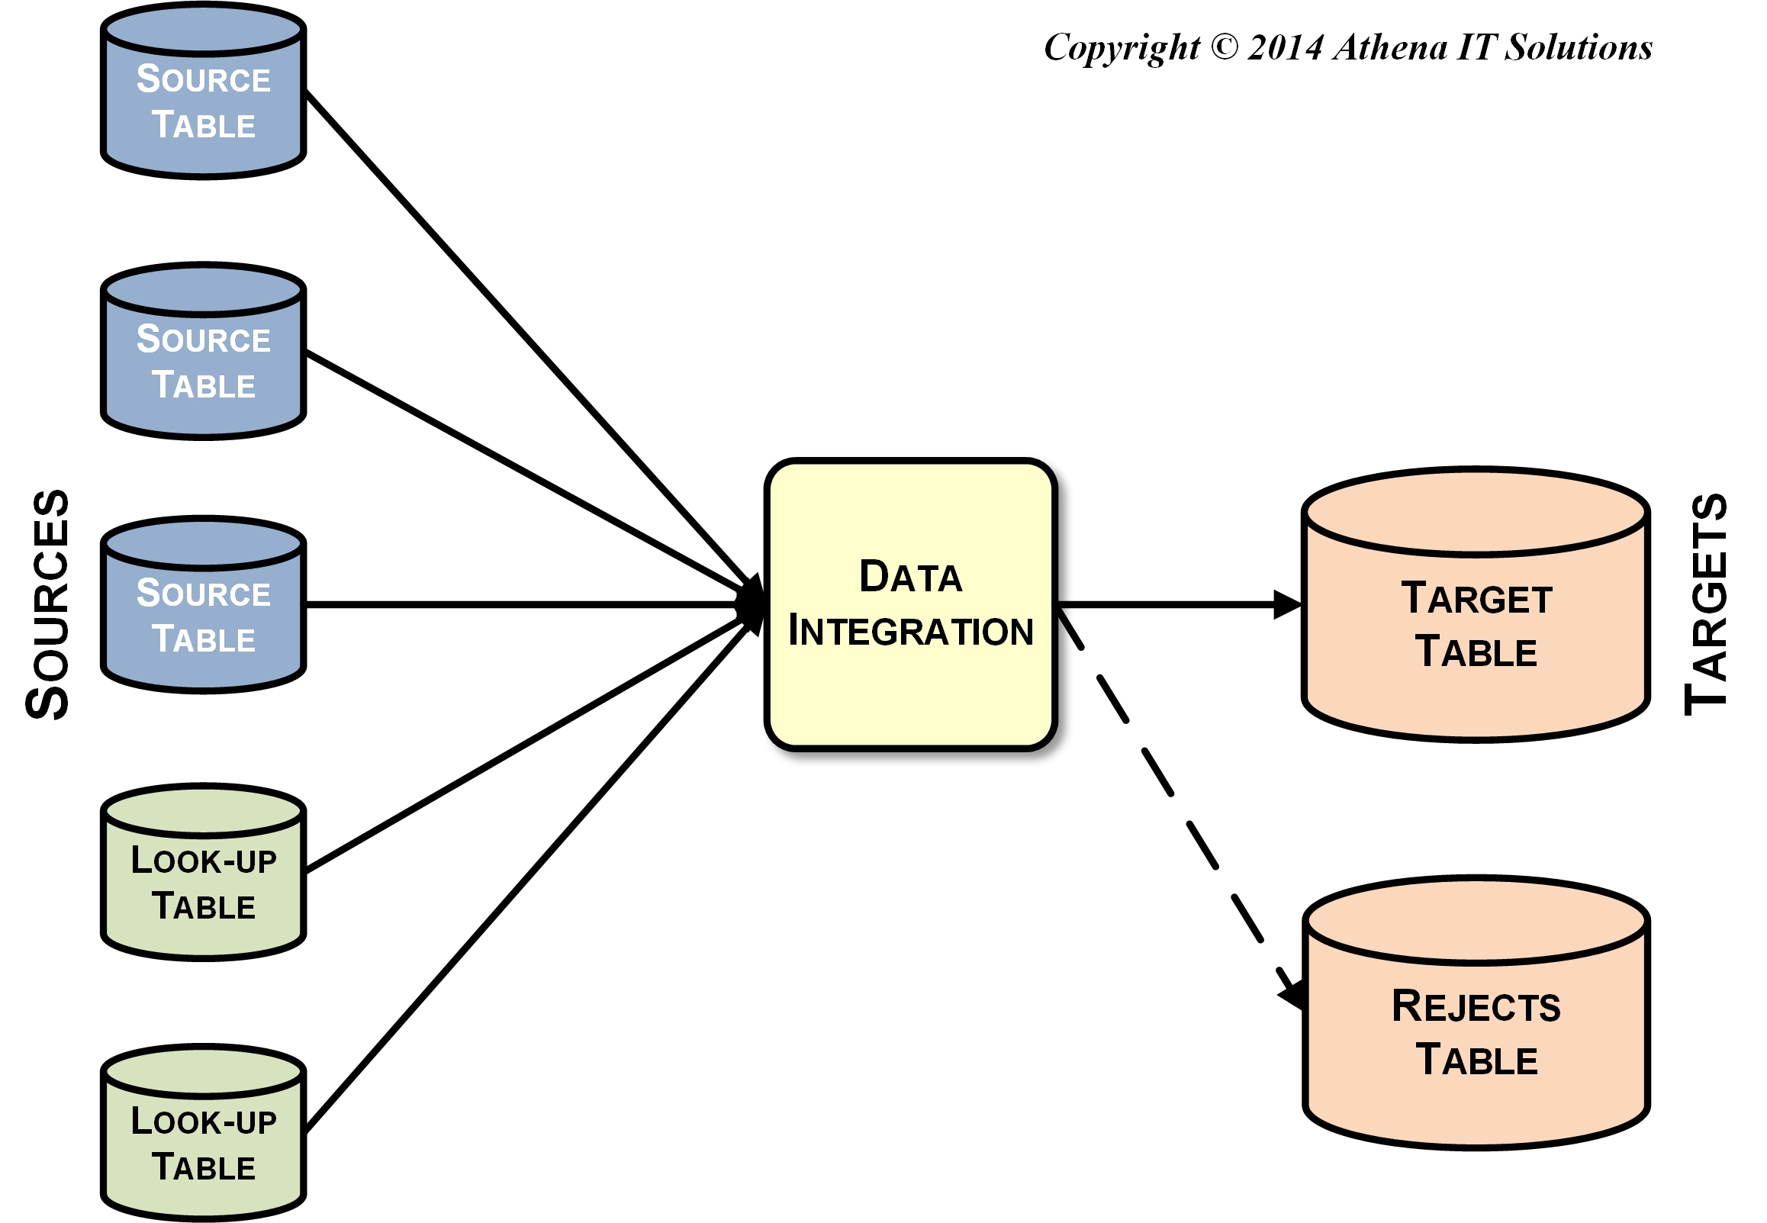

Figure : Source-to-Target Mapping Workflow Example

# Approvals

|  |  |
| --- | --- |
|  | It is a best practice to obtain sign-off approval of each project milestone. An organization’s policies and culture will dictate who the approvers will be, but typically the sponsors and key stakeholders are included. |

|  |  |  |
| --- | --- | --- |
| Title | Name | Approval  Date |
|  |  |  |
|  |  |  |
|  |  |  |
|  |  |  |
|  |  |  |

# Appendix: Background Materials

|  |  |
| --- | --- |
|  | This section includes all background or supporting materials for the BI Milestone Plan These materials may include:   * The milestone plan assumptions such as resources, funding, etc. * A more detailed project plan if defined |

## Authors and contributors

|  |  |
| --- | --- |
|  | List all the people involved in obtaining and analyzing the requirements along with the authors of this deliverable. |